Drago (slowly grows to a tree). Slowly being the word.
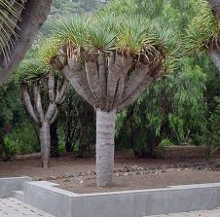 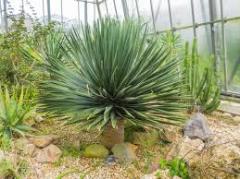
Tabaiba (low shrub) slowly grows from small plant to shrub maybe 1M X 1M after some years. Bare twigs some of the year.
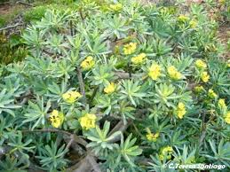
Lentisco (a tree if you have the room! drops red berries). Native to the Med, especially Greece, grows quickly/well on Fuerte, up to 7M if allowed. Happy to be severely pruned regularly.
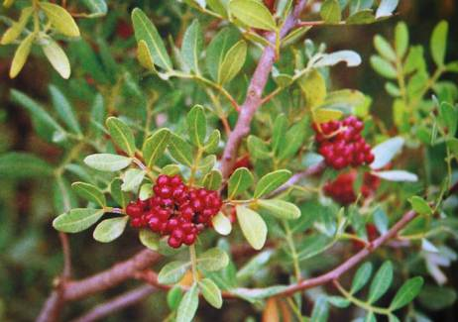

Tajiniste blanco (low shrub) member of the Echium family. I’ve seen one or two examples at 1M high but most seem to stay quite a bit smaller.
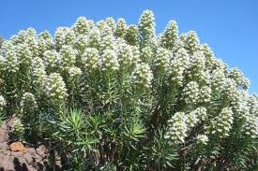
Cardon Canario (a cactus but not too vicious!) Starts with one or two upright arms and gradually/slowly fills out.
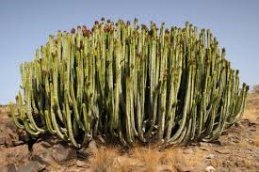
Algarroba (another tree but not quite as vigorous). Also known as Carob. Pods can be used for cocoa powder. Gets big but takes many years!
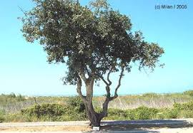 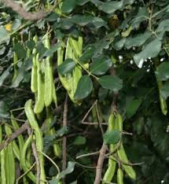
Yucca plain leaves or varieagated, the old leaves need stripping back once a year to stop it looking scruffy. Mature stems can be pruned severely to limit height growth. More side growths will then occur. Spectacular white/cream blooms.
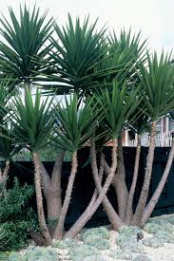

Agave - loads of varieties, some vicious, some softer leaves, sometimes die after flowering but takes quite a few years before flowering. Normally has put out small plants at base before it dies.
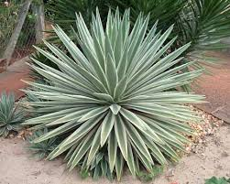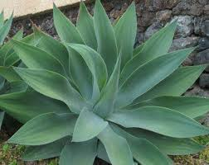

Aloe loads of varieties, most have prickles, some spectacular flowers, look after themselves. Medicinal properties.
