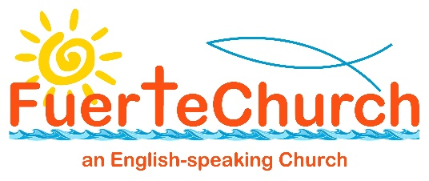

Chaplain’s Latest Update – 14/3/20 – 15:40
Things are changing almost as quickly as I can type updates. Various scenarios have changed and even different options this morning. All Catholic masses have been stopped on the island although churches will be open for personal prayer during the week. A variety of views have been expressed by the Chaplaincy Council members and the Archdeacon has said that as I am on the spot it is up to my judgement of the local situation. As I began writing there was a majority to continue but one member has just changed their view and now the council are 50:50.
Having looked in depth at all the information from health, government and church sources, at the moment we have cancelled the El Cotillo service but are still planning on having the one in Corralejo. After chatting with wardens we agreed to instruct people not to greet one another physically and to sit at least a metre apart (we can do this in Corralejo but not El Cotillo)
All the other measures we have put in place including single cups, retiring collection and no refreshments mean that we fulfil all possible measures in avoiding contact and keeping an excellent hygienic approach.
Measures just announced at 1pm today by the Government, which lockdown many facilities on the island including bars and restaurants and unnecessary travel also state, ‘As regards attendance at places of worship and civil and religious ceremonies, including funerals, "they are conditioned on the adoption of organizational measures consisting of avoiding crowds of people, depending on the dimensions and characteristics of the places, so that attendees are guaranteed the possibility of respecting the distance between them of at least one meter. "’
So watch this space. We are likely to have fewer people than normal but we are intending to video the whole service for those unable to attend.
Keep praying.
Love and blessings - Bob

